SCRAPPING OF MATERIALS

Home - Personal - Microsoft​ Edge
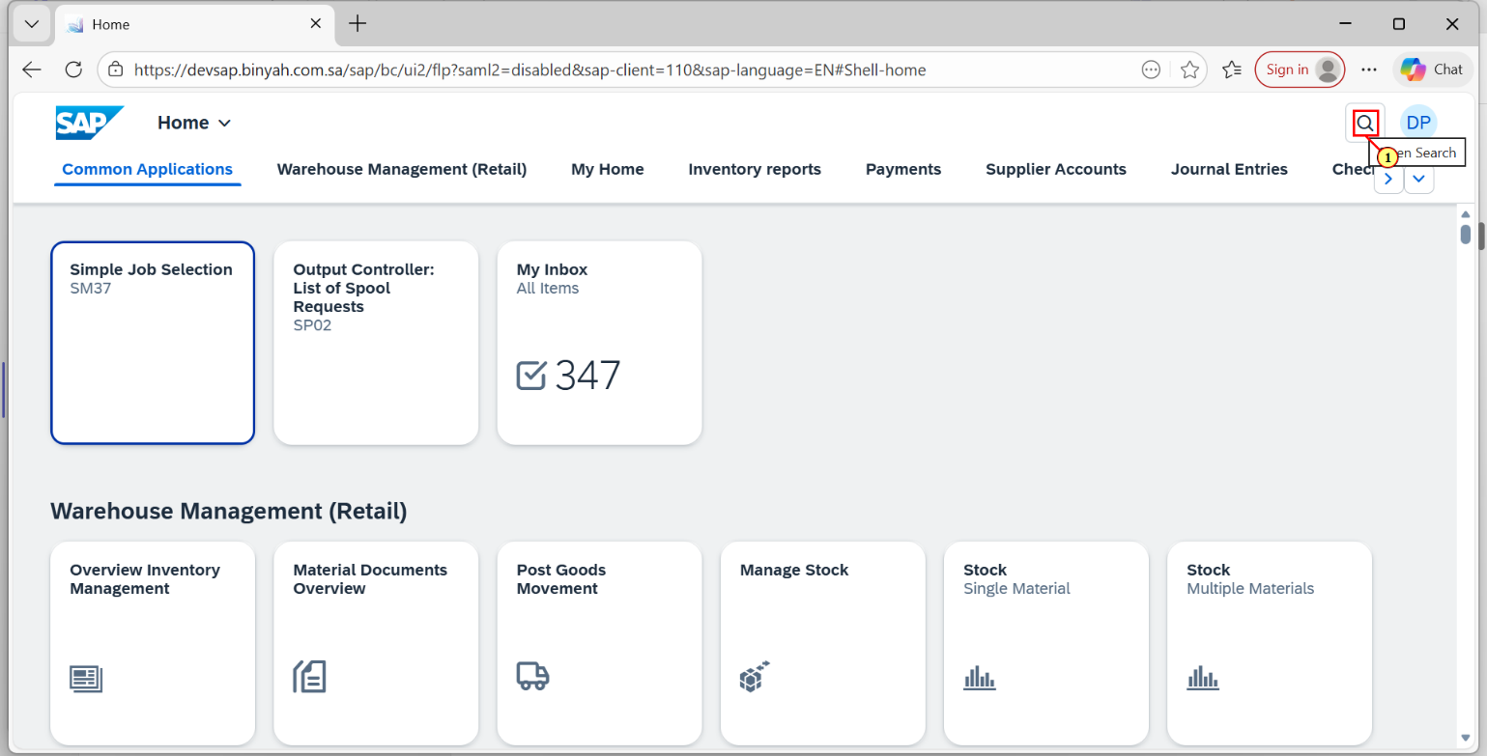
Step | Action
(1) | Click on Search Icon.

Home - Personal - Microsoft​ Edge
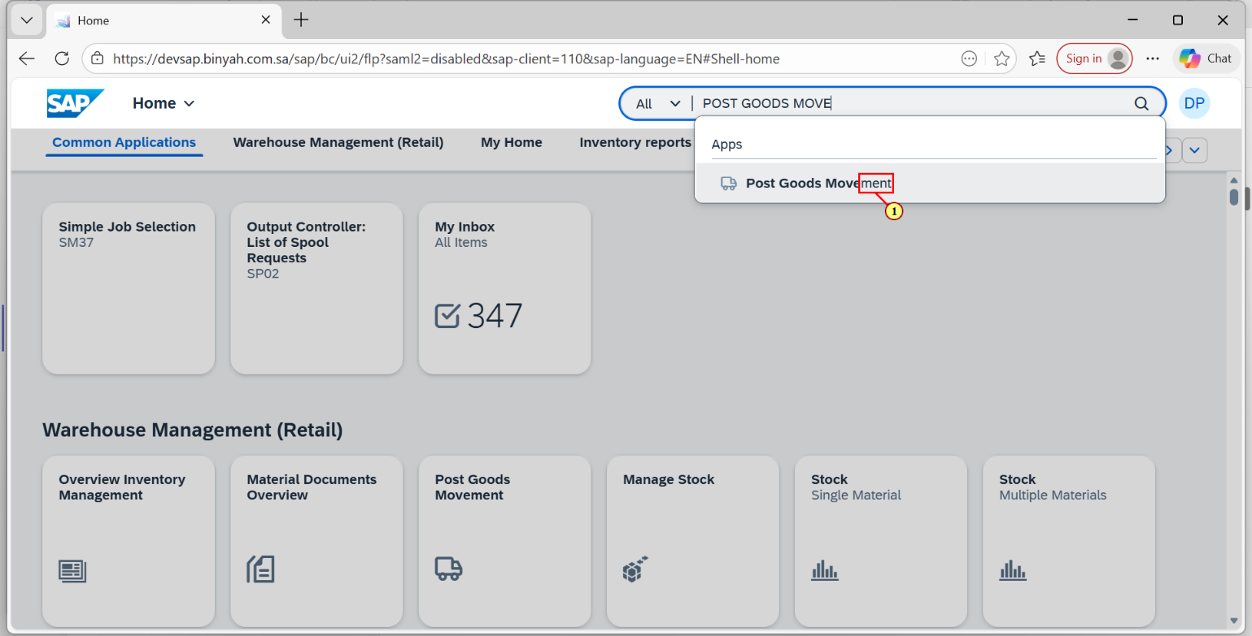
Step | Action
(1) | Search and Open "Post Goods Movement".

Goods Issue Other - Personal - Microsoft​ Edge
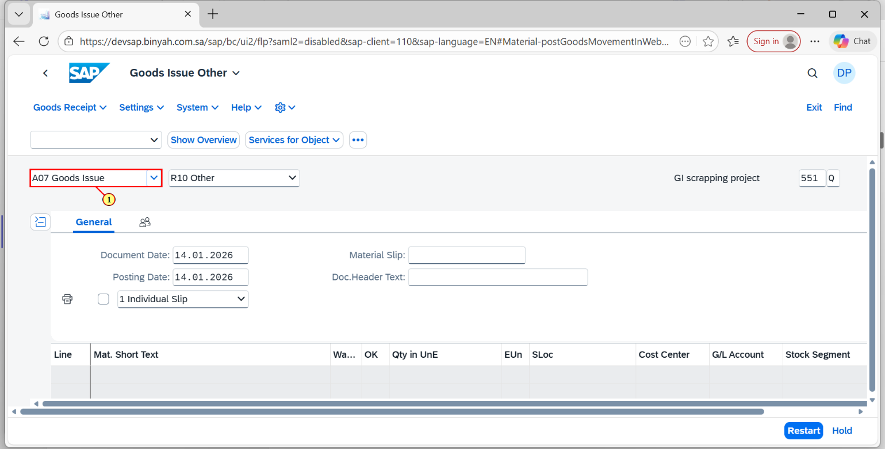
Step | Action
(1) | Select "Goods Issue".

Goods Issue Other - Personal - Microsoft​ Edge
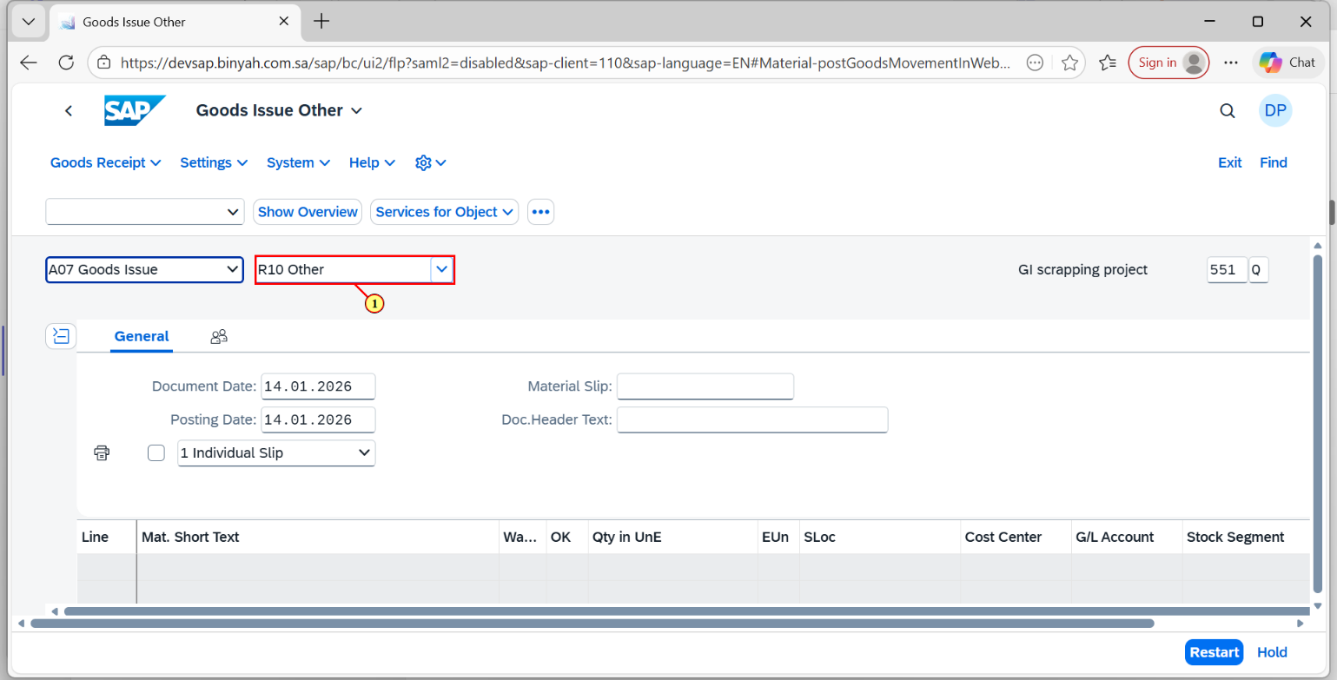
Step | Action
(1) | Select "Other".

Goods Issue Other - Personal - Microsoft​ Edge
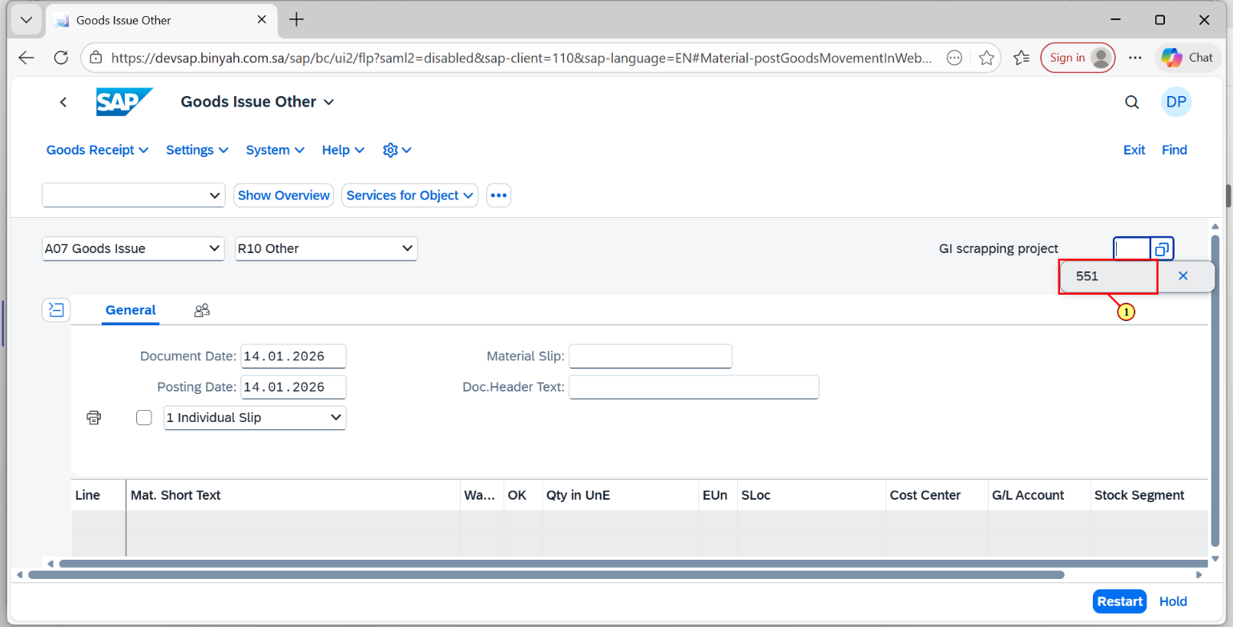
Step | Action
(1) | Enter the Movement Type as"551".

Goods Issue Other - Personal - Microsoft​ Edge
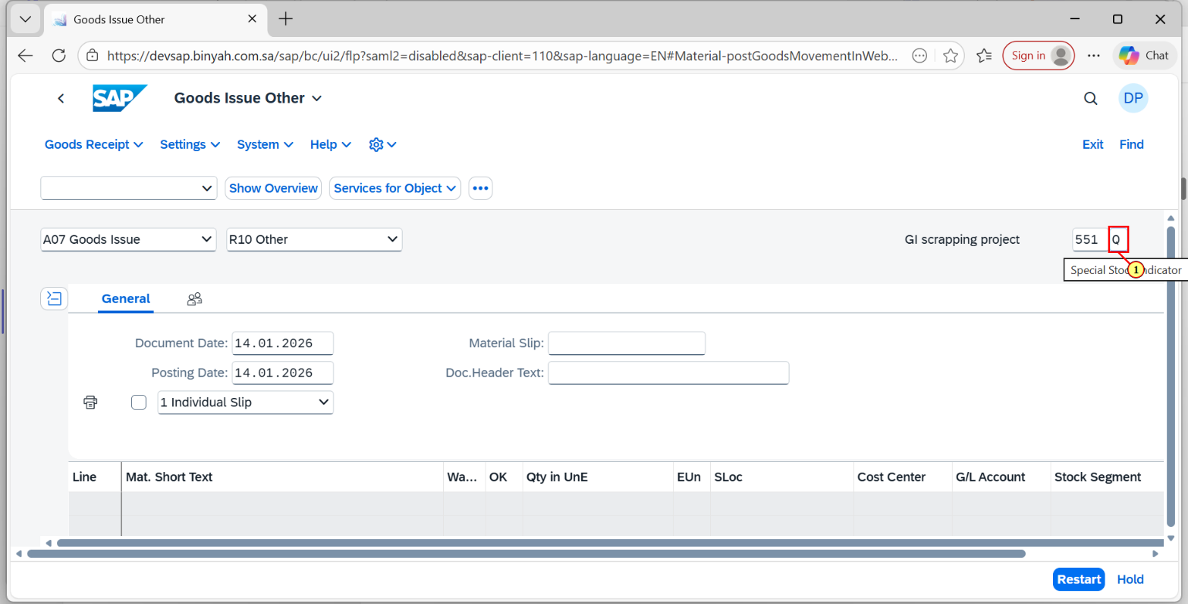
Step | Action
(1) | Enter the Special Stock Indicator as "Q".

Goods Issue Other - Personal - Microsoft​ Edge
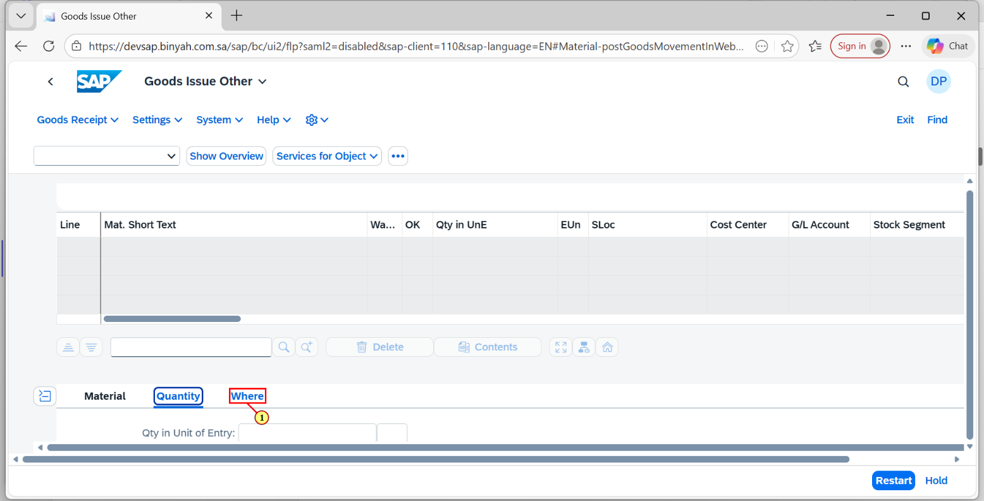
Step | Action
(1) | Click on "Where" Tab.

Goods Issue Other - Personal - Microsoft​ Edge
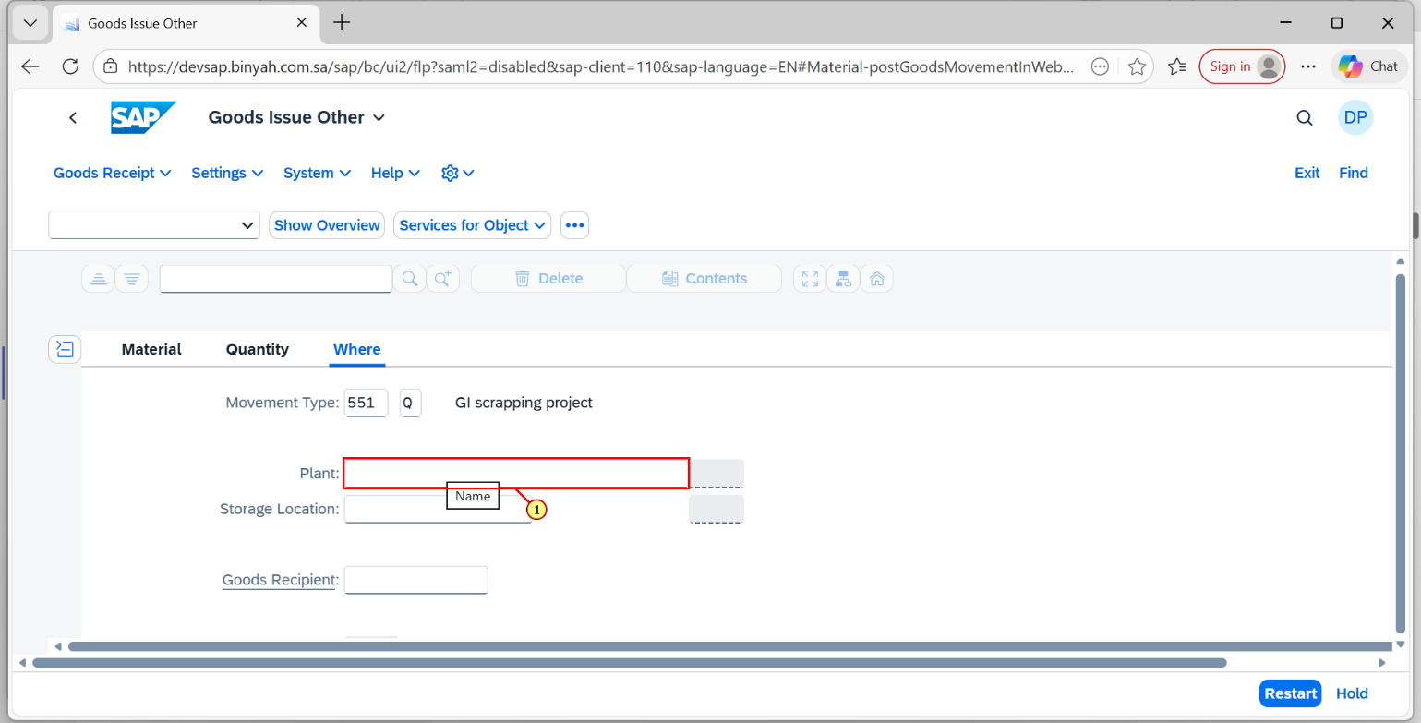
Step | Action
(1) | Enter "Plant".

Goods Issue Other - Personal - Microsoft​ Edge
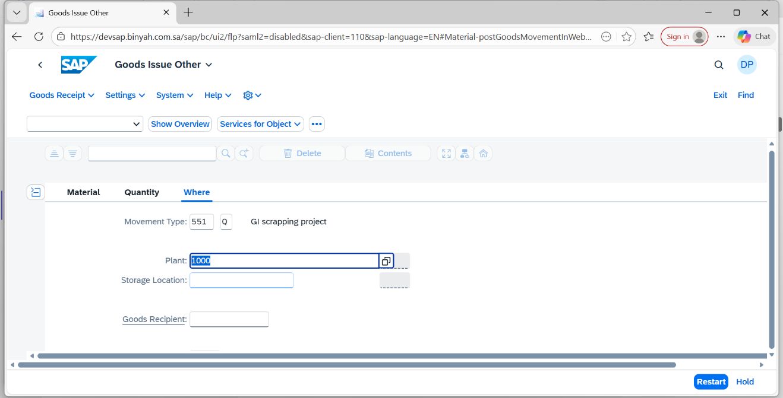
Step | Action
 | Press "Enter".

Goods Issue Other - Personal - Microsoft​ Edge
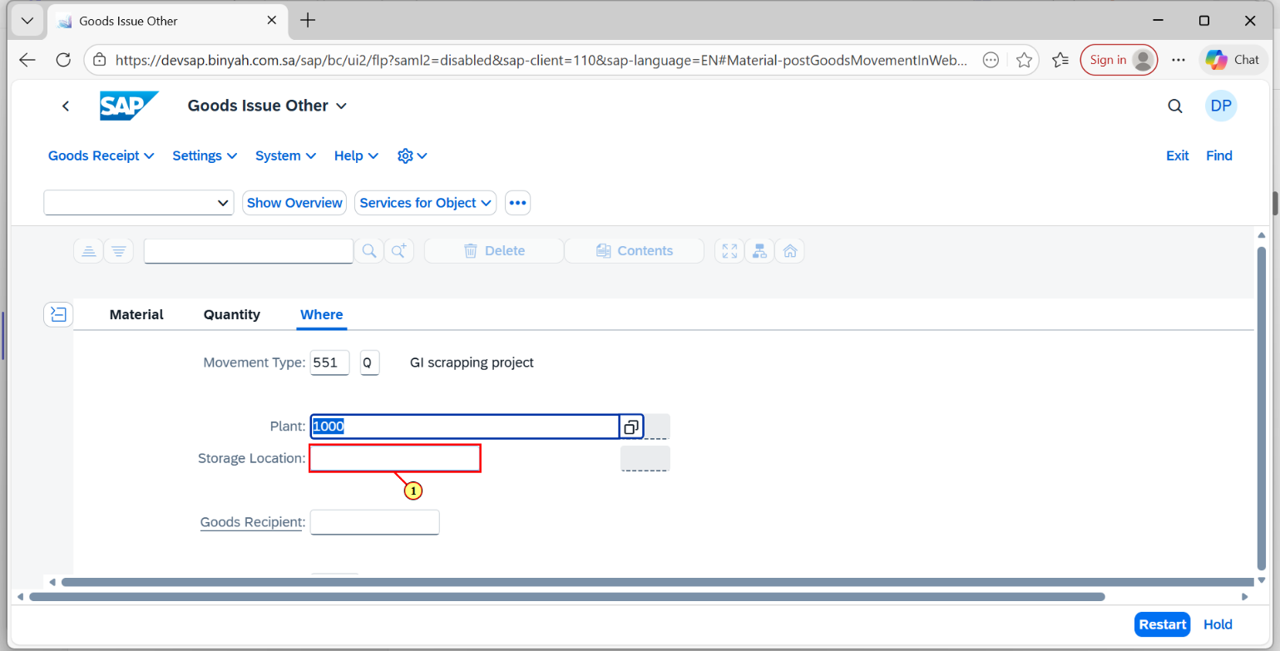
Step | Action
(1) | Enter "Storae Location".

Goods Issue Other - Personal - Microsoft​ Edge
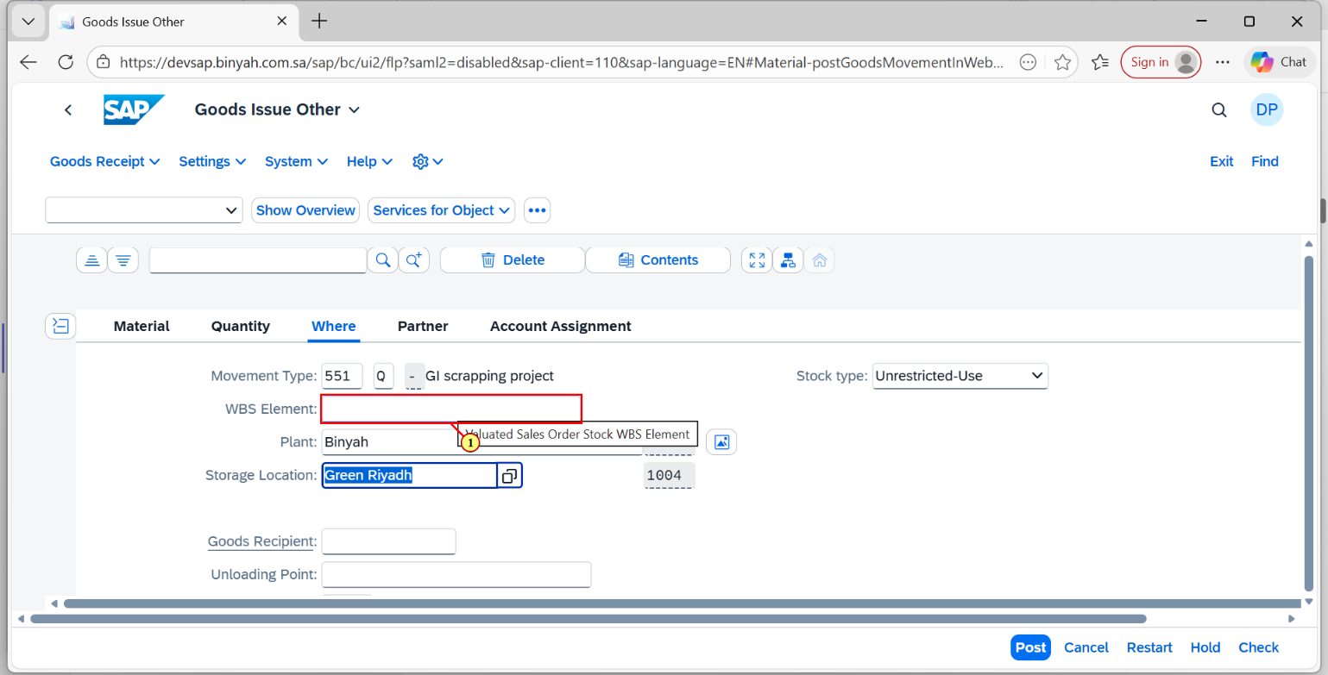
Step | Action
(1) | Enter "WBS Element".

Goods Issue Other - Personal - Microsoft​ Edge
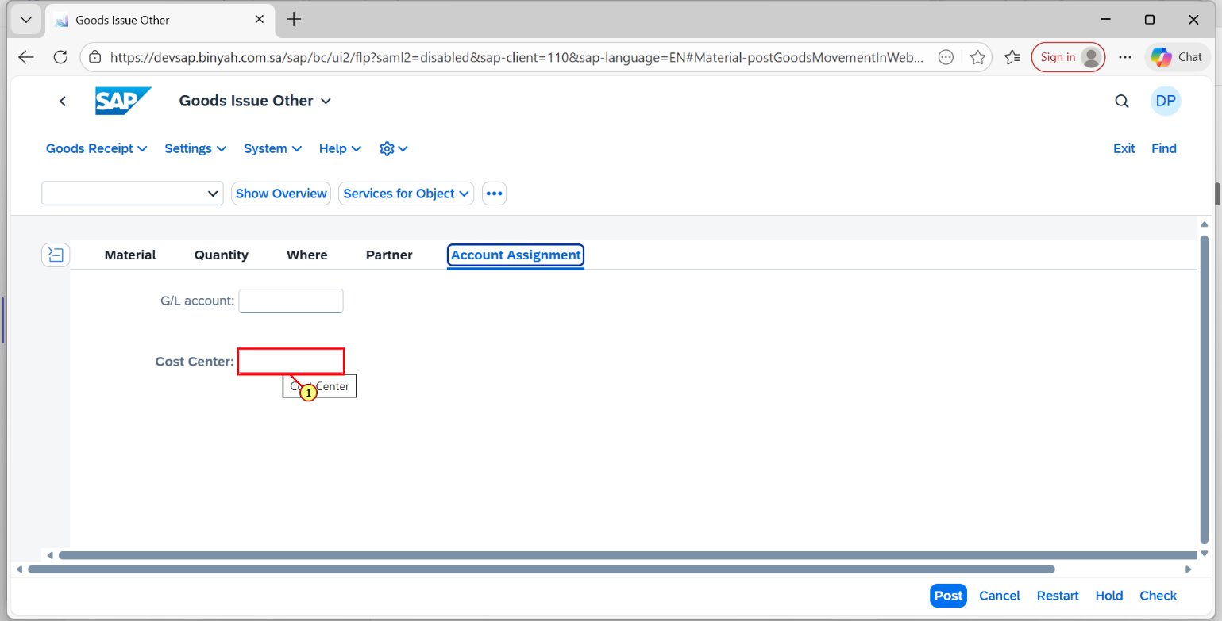
Step | Action
(1) | Click on "Cost Center".

Goods Issue Other - Personal - Microsoft​ Edge
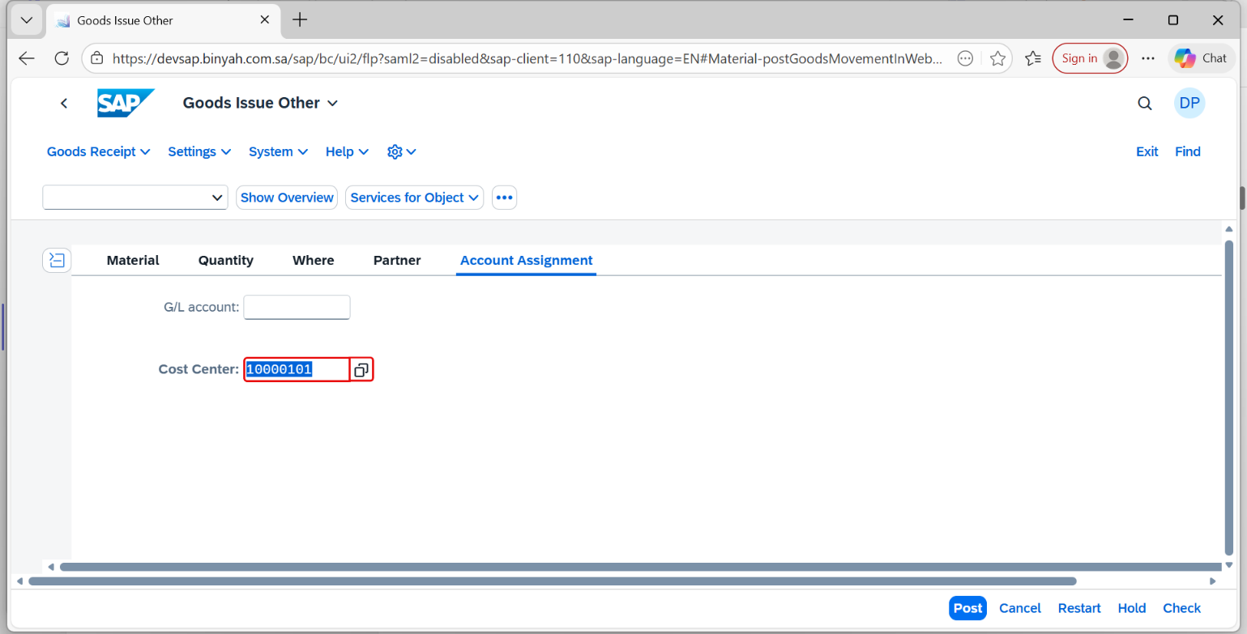
Step | Action
 | Press "Enter".

Goods Issue Other - Personal - Microsoft​ Edge
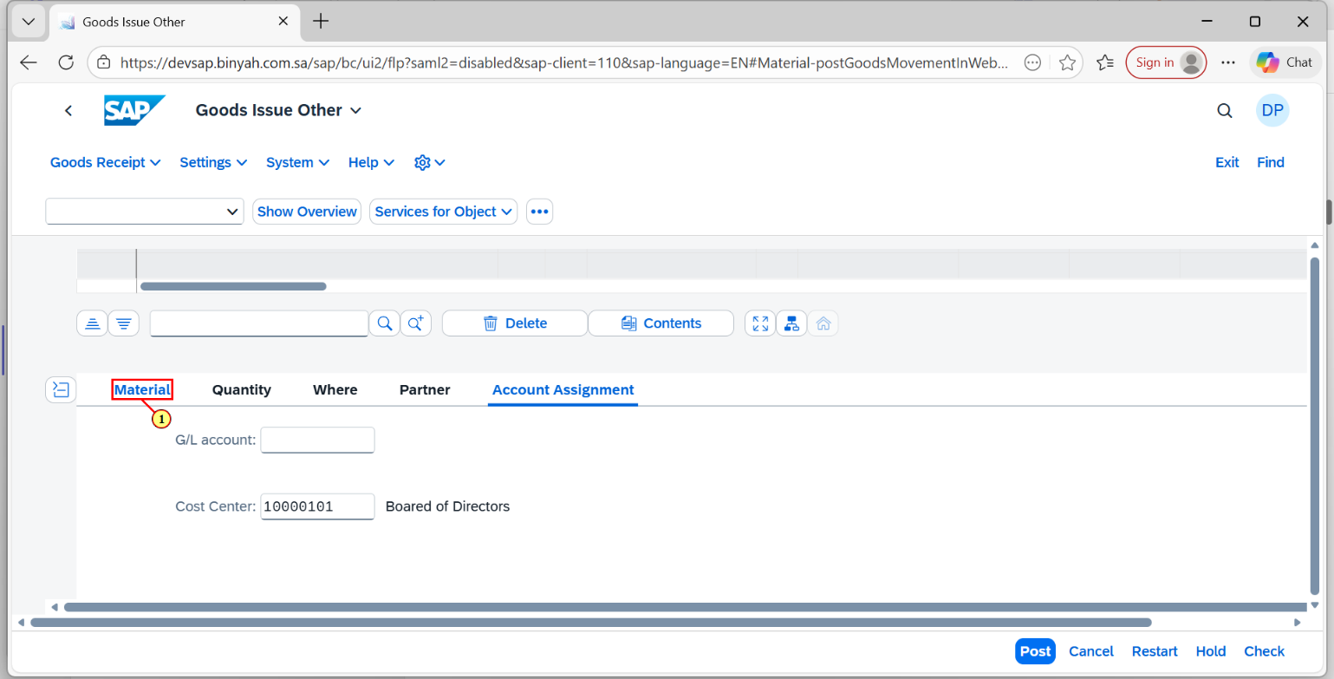
Step | Action
(1) | Click on "Material" Tab.

Goods Issue Other - Personal - Microsoft​ Edge
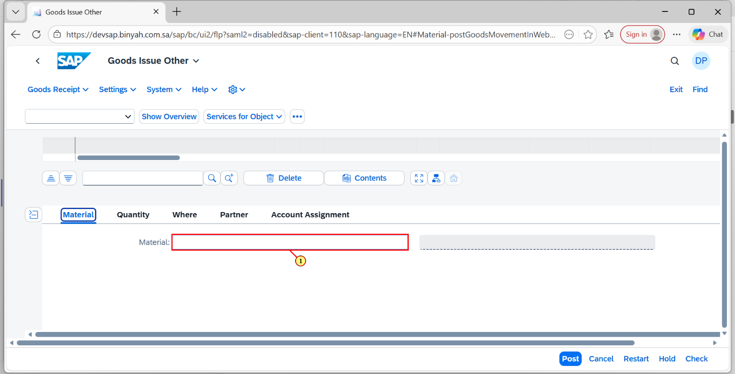
Step | Action
(1) | Enter "Material".

Goods Issue Other - Personal - Microsoft​ Edge
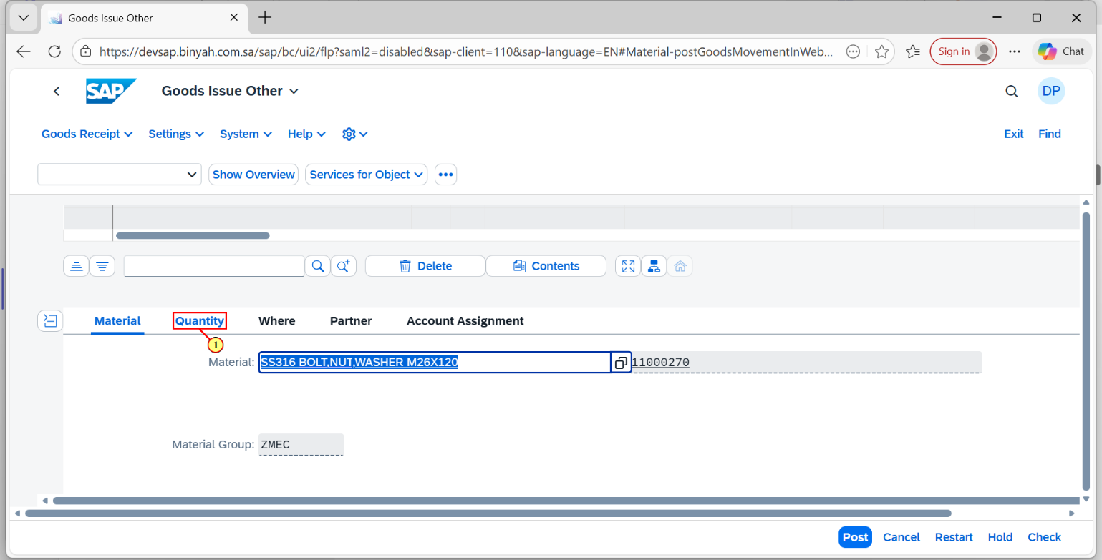
Step | Action
(1) | Click on "Quantity" Tab.

Goods Issue Other - Personal - Microsoft​ Edge
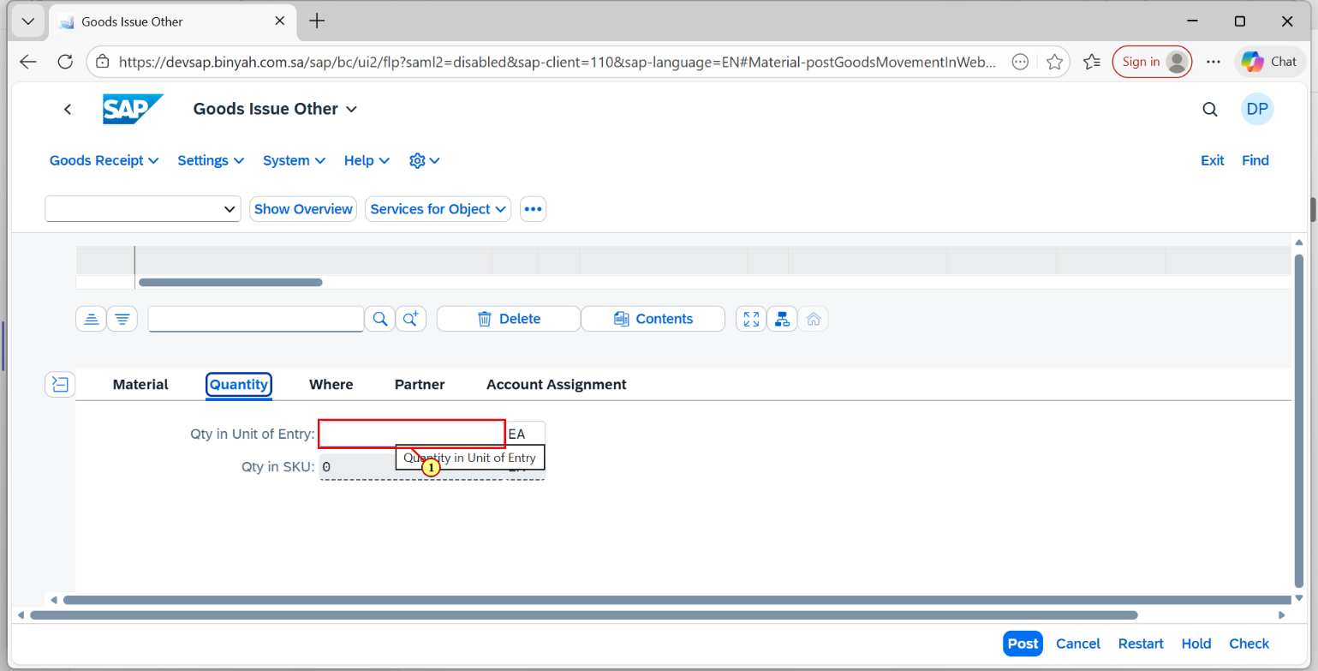
Step | Action
(1) | Enter the "Quantity".

Goods Issue Other - Personal - Microsoft​ Edge
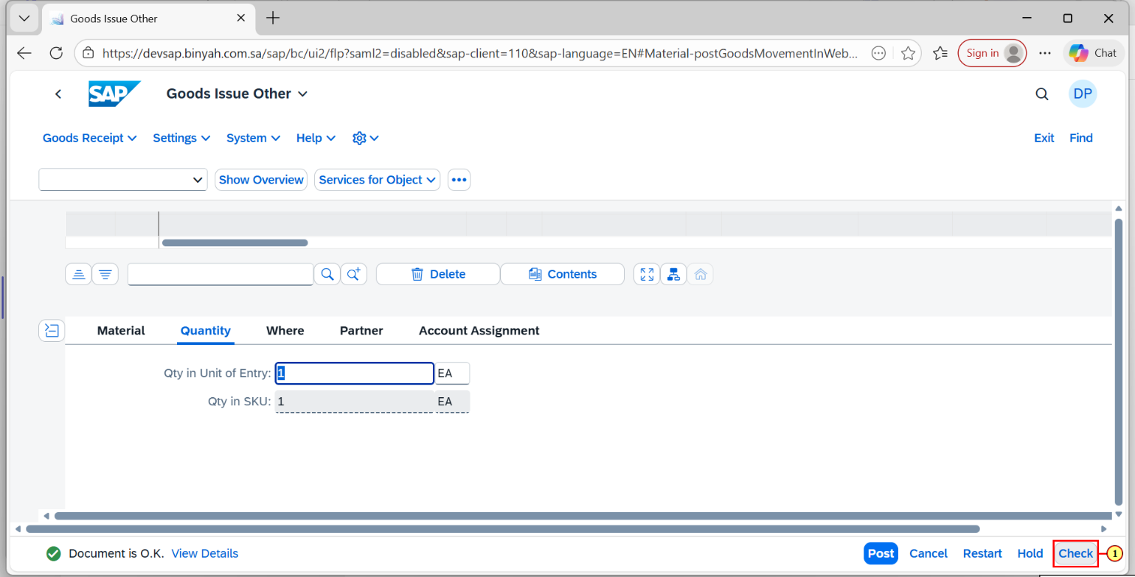
Step | Action
(1) | Click "Check".

Goods Issue Other - Personal - Microsoft​ Edge
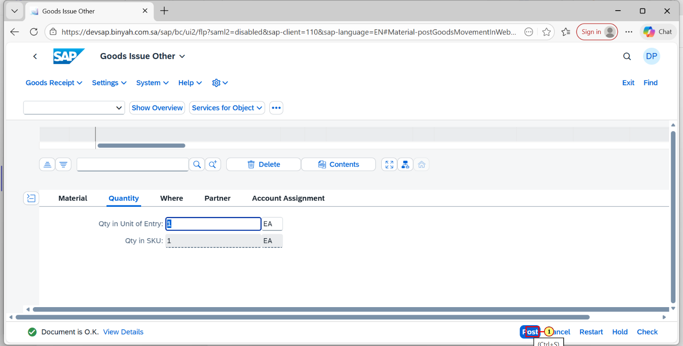
Step | Action
(1) | Click on "Post".

